Practice set-1 (Module-1)

Course: B.Tech (CSE) Year: III Semester: V Session: 2024-25 Subject Code & Name: BCSC-0011 (Theory of Automata & Formal Language)

- Language contain all strings of a’s and b’s with an input alphabet of ‘a’ and ‘b’, where each string starts with aa or bb.
- Language contain all strings of a’s and b’s with an input alphabet of ‘a’ and ‘b’, where each string contain substring ‘ab’.
- Language contain all binary strings, where each string contains 000, as a substring.
- Language contains all binary strings, where the decimal value of each string is divisible by 3.
- Language contains all strings of a’s and b’s with an input alphabet of ‘a’ and ‘b’, where each string contains a second symbol from the beginning is ‘a’.
- Language contains all strings of a’s and b’s with an input alphabet of ‘a’ and ‘b’, where each string contain second symbol from the ending is ‘b’ (ending with ‘ba’ and ‘bb’).
- Construct a minimal DFA for the regular language L={aW| W ϵ {a,b}*}
- Construct a minimal DFA for the regular language L={bW| W ϵ {a,b}*}
- Construct a minimal DFA for the regular language L={W₁aW₂| W1,W2 ϵ {a,b}*}
- Construct a minimal DFA for the regular language L={Wa| W ϵ {a,b}*}
- Construct a minimal DFA for the regular language L={aWb| W ϵ {a,b}*}
- Construct a minimal DFA for the regular language L={W| W ϵ {a,b}*, w has even length}
- Construct a minimal DFA for the regular language L={W| W contains exactly two a’s, W ϵ {a,b}*}
- Construct a minimal DFA for the regular language L={W| W contains at least two a’s, W ϵ {a,b}*}
- Construct a minimal DFA for the regular language L={W| W contains atmost two a’s, W ϵ {a,b}*}
- Construct a minimal DFA for the regular language L={W| W starts with and ends with the same symbols, W ϵ {a,b}*}
- Construct a minimal DFA for the regular language L={W| W starts with and ends with the different symbols, W ϵ {a,b}*}
- Construct a minimal DFA for the regular language L={W| W contains three consecutive a’s, W ϵ {a,b}*}
- Construct a minimal DFA for the regular language L={W| W contains a’s in every odd positions, W ϵ {a,b}*}
- Construct a minimal DFA for the regular language L={W| W contains b’s in every even positions, W ϵ {a,b}*}
- Construct a minimal DFA for the regular language L={W| W ϵ {a,b}*, W contains every a’s followed by exactly two b’s}
- Construct a minimal DFA for the regular language L={W| W ϵ {a,b}*, W contains all a’s followed by all b’s} = {a^{m}b^{n}/ m,n≥0}.
- Construct a minimal DFA for the regular language L={W| W ϵ {a,b}*, W contains all a’s followed by single b} = {a^{m}b/ m≥0}.
- Construct a minimal DFA for the regular language L={W| W ϵ {a,b}*, number of b’s in w is divisible by 3}
- Construct a minimal DFA for the regular language L={W| W ϵ {a,b}*, |w|mod3=0}
- Construct a minimal DFA for the regular language L={W| W ϵ {a,b}*, |w|mod3≥0}
- Construct a minimal DFA for the regular language L== {a^{m}b^{n}/ m≥1,n≥1}
- Construct a minimal DFA for the regular language L== {a^{m}b^{n}/ m=2,n=1}
- Construct a minimal DFA for the regular language L == {a^{3n}b^{2m} | n,m ≥ 1}
- Construct a minimal DFA for the regular language L == {xaw/ x ϵ {a,b}, w ϵ {a,b}* }
- Construct a minimal DFA for the regular language L={Wbb| W ϵ {a,b}* }
- Construct a minimal DFA for the regular language L={W| (Number of b’s in w) mod5<2, W ϵ {a,b}* }
- Construct a minimal DFA for the regular language L== {1^{n}/ n≥0, ∑ = {1}}
- Construct a minimal DFA for the regular language L== {1^{2n+1}/ n≥0, ∑ = {1}}
- Construct a minimal DFA for the regular language L== {1^{3n+2}/ n≥0, ∑ = {1}}
- Construct a minimal DFA for the regular language L== {1^{3n}/ n≥1, ∑ = {1}}
- Construct a minimal DFA for the regular language L== {1^{3n}/ n≥0, ∑ = {1}}
- Construct a minimal DFA for the regular language L== {1^{3n+1}/ n≥1, ∑ = {1}}
- Construct a minimal FA for the regular language L={Wa| W ϵ {a,b}* }
- Construct a minimal FA for the regular language L={W₁a W₂| W₁, W₂ϵ {a,b}* }
- Construct a minimal FA for the regular language L={aWa| W ϵ {a,b}* }
- Construct a minimal FA for the regular language L= {W| W contains exactly two a’s, W ϵ {a,b}* }
- Construct a minimal FA for the regular language L= {W| W contains atleast two a’s, W ϵ {a,b}* }
- Construct a minimal FA for the regular language L= {W| W contains atmost two a’s, W ϵ {a,b}* }
- Construct a minimal FA for the regular language L= {W| W ϵ {a,b}*, |W| =3 }
- Construct a minimal FA for the regular language L= {W| W ϵ {a,b}*, |W| ≤3 }
- Construct a minimal FA for the regular language L= {W| W ϵ {a,b}*, |W| ≥3 }
- Construct a minimal FA for the regular language L= {W| W start with either aa or bb, W ϵ {a,b}*}. i.e. L = (aa+bb) (a+b)*.
- Construct a minimal FA for the regular language L= {W| W ends with either aa or bb, W ϵ {a,b}*}. i.e. L = (a+b)* (aa+bb).
- Construct a minimal DFA for the regular language L={{}| W ϵ {a,b}*}
- Construct the equivalent DFA for the following NFA
- Construct the equivalent DFA for the following NFA
- Construct the equivalent DFA for the following NFA
- Construct the equivalent DFA for the following NFA

- Construct the equivalent DFA for the following NFA
- Construct the equivalent DFA for the following NFA

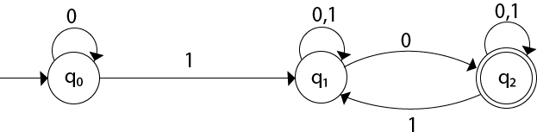
- Construct the equivalent DFA for the following NFA

State/∑ | 0 | 1 | 2
q0⁻ | q1q4 | q4 | q2q3
q1 | - | q4
q2 |  |  | q2q3
q3⁺ |  | q4
q4

- Construct the equivalent DFA for the following NFA
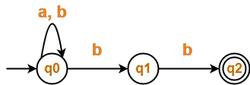
- Construct the equivalent DFA for the following NFA
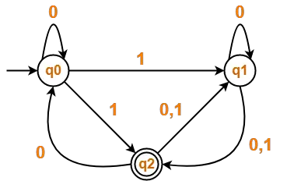
- Construct the equivalent DFA for the following NFA
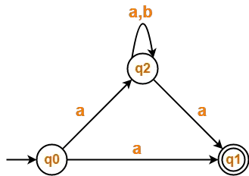

- Construct the equivalent DFA for the following NFA
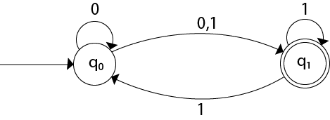
- Construct the equivalent DFA for the following NFA
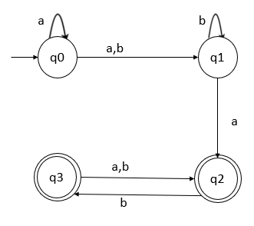

- Construct the equivalent DFA for the following NFA
State/∑ | 0 | 1
->P+ | QS | Q
Q+ | R | RQ
R | S | S
S | - | P

- Minimize the following DFA and execute all the steps of minimization
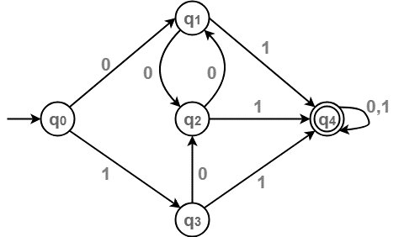
- Minimize the following DFA and execute all the steps of minimization
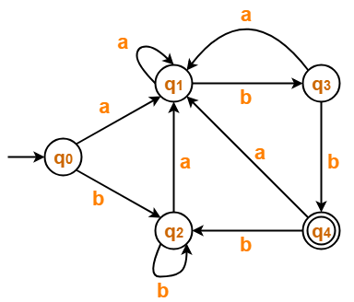
- Minimize the following DFA and execute all the steps of minimization
- Minimize the following DFA and execute all the steps of minimization
- Minimize the following DFA and execute all the steps of minimization
- Minimize the following DFA and execute all the steps of minimization
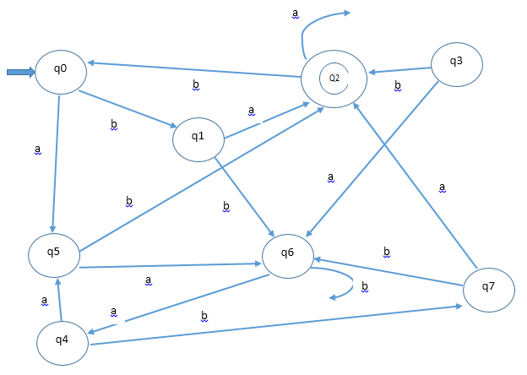
- Minimize the following DFA and execute all the steps of minimization
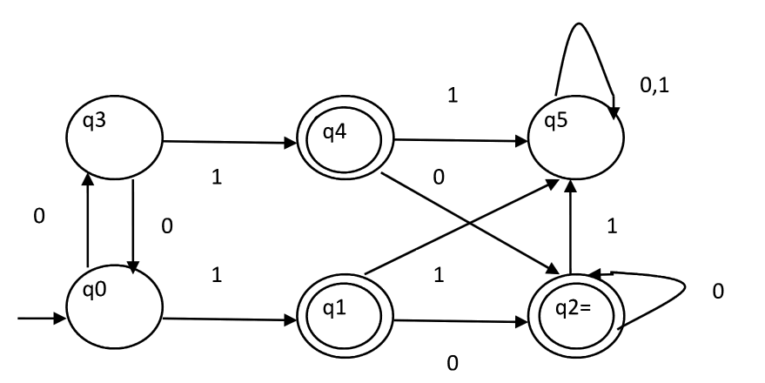

- Minimize the following DFA and execute all the steps of minimization
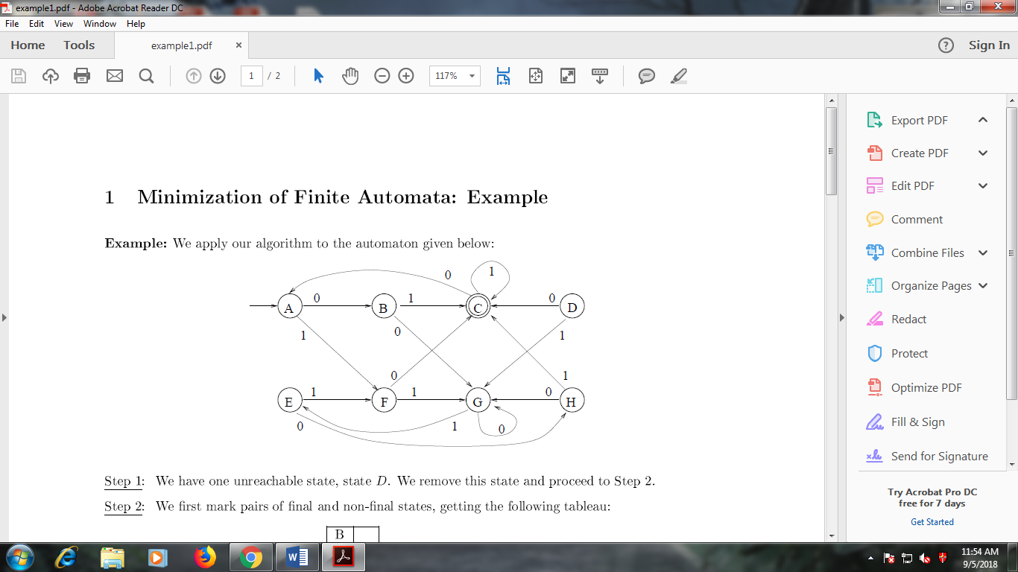
- Minimize the following DFA and execute all the steps of minimization
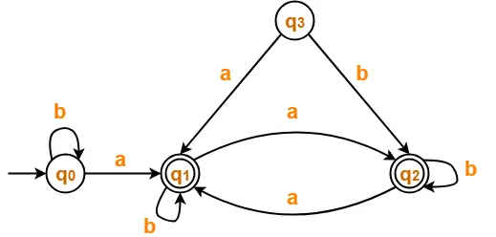

- Minimize the following DFA and execute all the steps of minimization
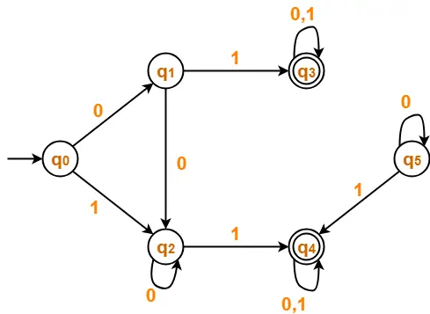
- Minimize the following DFA and execute all the steps of minimization
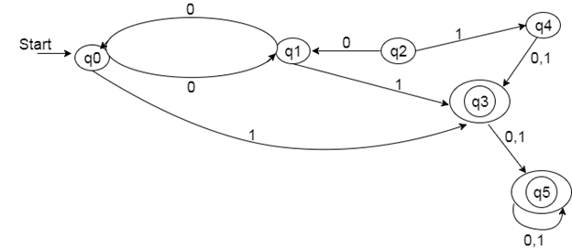
- Construct a Moore machine that generates an output X for every occurrence of ‘a’ in the input string. Otherwise, it generates output Y. Consider input language is over the symbols of ‘a’ and ‘b’.
- Construct a Moore machine that generates an output X for every occurrence of ‘aa’ in the input string. Otherwise, it generates output Y. Consider input language is over the symbols of ‘a’ and ‘b’.
- Construct a Moore machine that produces an output X for each occurrence of ‘01 in the input string, that produces an output Y for each occurrence of ‘10. Otherwise, it generates output Z. Consider input language is binary language.
- Construct a Moore machine that produces 1’s complement of a binary number.
- Construct a Moore machine that produces 2’s complement of a binary number.
- Construct a Moore machine that produces addition of two binary numbers.
- Construct a Moore machine that counts the occurrence of 001 in the input binary string.
- Construct a Mealy machine that generates an output X for every occurrence of ‘a’ in the input string. Otherwise, it generates output Y. Consider input language is over the symbols of ‘a’ and ‘b’.
- Construct a Mealy machine that generates an output X for every occurrence of ‘aa’ in the input string. Otherwise, it generates output Y. Consider input language is over the symbols of ‘a’ and ‘b’.
- Construct a Mealy machine that produces an output X for each occurrence of ‘01 in the input string, that produces an output Y for each occurrence of ‘10. Otherwise, it generates output Z. Consider input language is binary language.
- Construct a Mealy machine that produces 1’s complement of a binary number.
- Construct a Mealy machine that produces 2’s complement of a binary number.
- Construct a Mealy machine that produces addition of two binary numbers (binary full adder).
- Construct a Mealy machine that change the sign bit of the binary number.
- Construct a Mealy machine that calculates bitwise XOR of two binary numbers.
- Construct a Mealy machine that counts the occurrence of 001 in the input binary string.
- Construct a Mealy machine that produces A for every occurrence of 00 in an input binary string, otherwise produce B.

